Trial 1

Subject 1 Description

80 yr old caucasian male, married, retired Ford engineer, currently works as a tax accountant for H&R Block.

Trial 1

Transcript

Phillip: Okay, so I should probably read the script before we get started (clears throat), “Thank you for agreeing to participate in our university study on interfaces. We are UM Flint students studying Human-Computer Interaction. The system we are demoing is the Steam game platform. The Steam platform is a system that can be used to buy, install, launch and communicate about computer games, as well as with other users. We will be asking you to perform several tasks for this demo. The first task is to use Steam to purchase a game.

Um, please do the following: Launch the Steam application. Open the Steam store. Search the store for the game we have designated for you (Destiny 2). Purchase the game for the demo account using the card information we have supplied. After purchase, follow the instructions provided by Steam and the selected game (Destiny 2) to download and install...such game (Destiny 2) to the provided computer. Next, you are to use Steam to run a computer game. Assume you would like to play a game...To do so, please do the following(.) Open the game library. Select or search for the game you would like (Destiny 2). Launch the game (Destiny 2) from the game’s page in the steam application. Because we are not testing Destiny 2 itself, please exit the game so we can continue the study. The following task is to use Steam to install a beta update for an already installed game. Please do the following: Return to the Steam game library. Select or search for the desired game (Destiny 2). Modify the Steam options for the game to allow beta updates. Enter the beta key we have provided you. Accept the beta conditions. The final task is to use Steam to send another user a text message. Open the Friends window. Select a friend (Bob), send the user (Bob) a message.

Thank you for your participation. Please answer the questionnaire to assist in our research.

User: (whistles) That’s a lot to do for one game. (laughs)

Phillip: It’s what we gotta do. Anyway, uh, you don’t actually have to purchase the game because I already have it, so you’ll just need to make your way to its page on the Steam store and click the “Play game” button.

User: O:::kie dokie, then.

(User proceeds to open the Steam store to the ‘Featured’ page. His eyes widen and he stares for two seconds.)

User: Now where’s the-oh.

(User moves the mouse cursor across the page before noticing the search bar. He clicks it and types in “Destiny 2.” When the drop-down menu appears, he hovers the mouse over the first option.)

User: That one?

Phillip: Yeah.

(The user clicks on it.)

Phillip: Okay, now we just need to actually start the game up.

User: And how do I do that?

Phillip: Well, first, you gotta get to the games library page. (pause) Up there.

(Phillip points to the top of the Steam store page. The user moves the mouse up to click the “Library” button.)

Phillip: Now just find Destiny 2.

(User looks at the games sidebar and scrolls down until he sees Destiny 2.)

User: So now we install it?

Phillip: I, uh, it’s already installed. If we did install it, we’d be here for at least forty minutes doing jack-s**t. (laughs)

User: Oh. So now what?

Phillip: Just run the game.

(User clicks on the game and pauses to study the game hub window on the right side of the screen before clicking “Play.”)

User: [as the game loads] Beautiful art. Think you could do something like that?

Phillip: (scoffs) Doubt it...Alright, you can close it, uh, whenever.

(User closes the game.)

Phillip: Okay, last part...change the game to a beta version.

User: And what does that mean?

Phillip: Just means switching to an earlier version of the game. Right click on the name...

(Phillip points to Destiny 2 in the sidebar, and the user right-clicks it.)

Phillip: Click “Properties...”

(User clicks the “Properties” option.)

Phillip: ...And now just [User clicks on “Betas” tab] Yeah, that’s it.

User: Now what do you need me to do?

Phillip: Normally, you’d...uh (.) pick a version of the game, but since Destiny doesn’t have a beta version to use, just exit out.

(User clicks the “Close” button on the lower-right side of the window.)

Phillip: Okay, last, uh...send a friend a message. Don’t actually send anything just, show you can [do it].

User: Okay.

(User looks around before noticing the “Friends and Chat” tab in the lower right corner and clicks it. The Friends menu appears. User clicks on the arrow next to “THORS-HAMMR” and clicks “Send Message.”

Phillip: Okay, we’re done. Gimme a minute (rustling) Okay, uh, ending recording.

Trial 1

Questionnaire

1. Have you ever used a computer before? “Yes”
   1. If so, how often? “About seven hours per day.”
2. Have you ever used Steam? “No”
   1. If so, how often?
3. Have you ever played a computer game before? “No”
   1. If so, how often?
4. Have you ever used a competing platform, such as Origin? “No”
   1. Would you describe the other platform's experience as being better than Steam's?
5. Do you usually run Steam to do a specific task? “No”
6. What is usually the first thing you do when you run Steam? “I would check the game library.”
7. How many games are in your favorites list? “None”
8. Have you ever manually installed an update for a game? “No”
   1. Why did you install the update manually?
9. How do you usually add games to your Steam library? “I don’t.”
10. How do you normally communicate with friends while playing a game? “I don’t.”
11. What was your most used function of Steam? “The search bar…?”
12. What was your biggest challenge/obstacle faced during the testing process? “Trying to understand how the properties tab work.”
13. Rank Steam experience (1-10) 1-Terrible & 10-Amazing: “5 - Wasn’t great, wasn’t terrible.”
14. Rank *Destiny 2* experience (1-10) 1-Terrible & 10-Amazing: “6 - I didn’t play it, but it sure looks flashy.”

Trial 1

Artifact Model

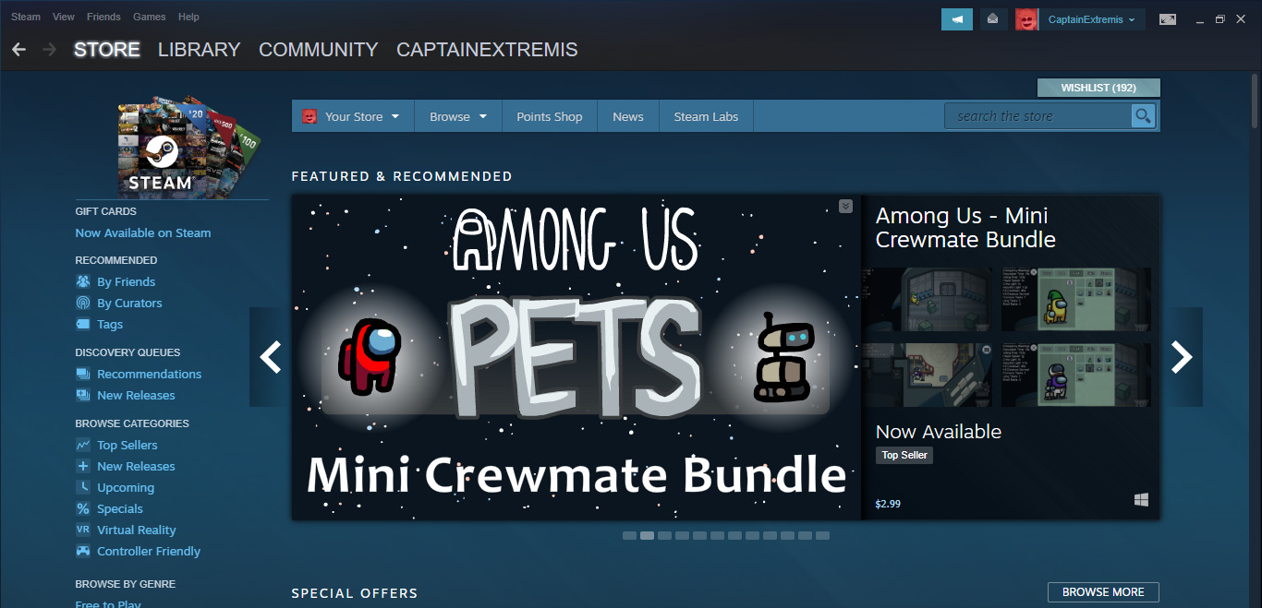

Main store page.

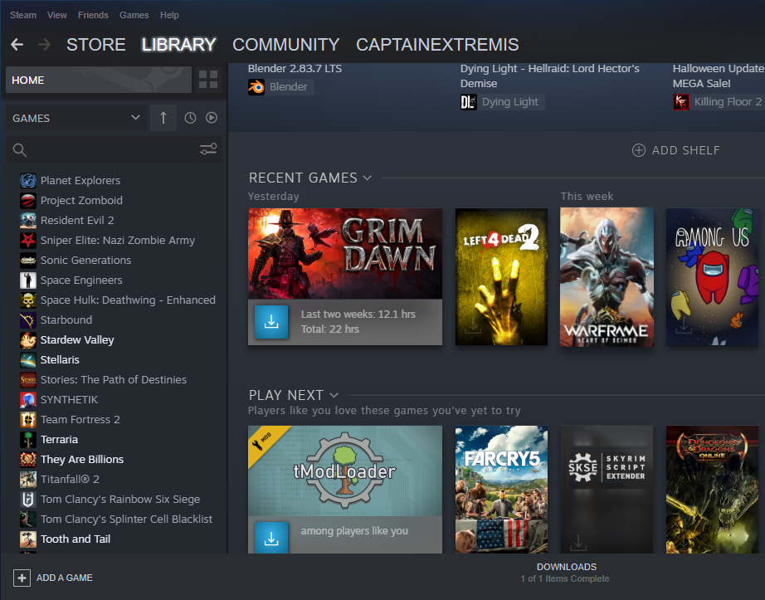

Steam library page of the interviewer.

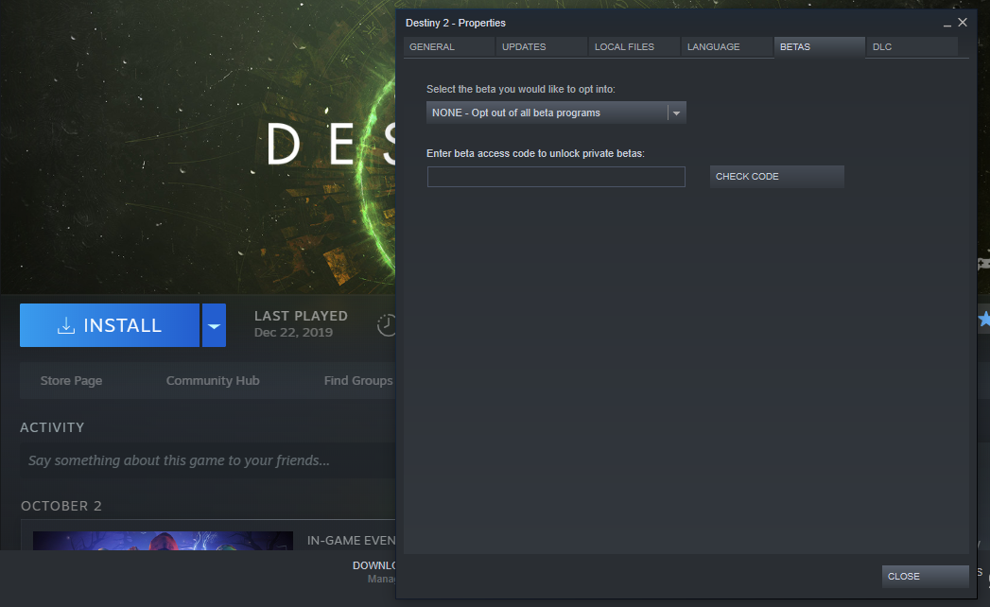

Destiny 2 beta program tab.

Trial 2

Subject 2 Description

White Caucasion; 51 years of age; female. Works remotely from home for Consumers Energy. Has been using computers for 15 or more years. College degree in Sociology and Psychology from UM - Ann Arbor.

Trial 2

Transcript

00 (Start Test)

1. Cason: Alright, to start I’ll have you read the Script.
2. User: Okay. (user reads script). *Figure 1*
3. Cason: Now, you will do your best to execute the script, I will be here to help and answer any questions you have.
4. User: So, I am going to click on the search icon & type in Steam. *Figure 2*
5. User: The Steam app came up, so I am going to click on it. *Figure 2*
6. User: The next thing I need to do is open the Store. (User was already in the store at this time).
7. Cason: Okay so it was redundant to put in open the store.
8. User: Search the store for the designated game, Destiny 2. *Figure 3*
9. User: So destiny 2 came up. *Figure 4*
10. User: Purchase the game for the demo account; So I’ve got to figure out how to do that…
11. Cason: Scroll… It’s free.
12. User: So I would just go to play game? (Could change script to make more clear).
13. Cason: yeah.
14. User: So that’s purchasing it but I wouldn't know. (Starts download). *Figure 5*
15. Cason: Okay, so now we are going to take a pause because this will take a few hours.
16. Cason: Alright so we let the install run for 2-3 hours; it has completed its course; the screen has updated and we are at the next task.
17. User: Reads Script. (now at playing the game).
18. Cason: You could just hit play now. (hits play now) *Figure 6* Skips *Figure 7&8*
19. User: Says an error occurred. (app running; exits error and game). Skips *Figure 9*&10*
20. User: Okay so the next task is to use the friends tab to add a friend. *Figure 11*
21. User: Uhhh Friend code? *Figure 12*
22. Cason: This is also a scrollable page. *Figure 12*
23. User: Try searching for your friend Bob. *Figure 12*
24. User: To finish click add the as user. (not what the script says). *Figure 13*
25. User: Open the friends window, select bob? *Figure 14*
26. Cason: You might have to hit view friends. *Figure 14*
27. User: View friends list, ok. *Figure 14*
28. User: I see online friends, so Bob isn’t on there. (Bob needs to accept a friend request). *Figure 15*
29. Cason: You might not even be able to send Bob a message. *Figure 15*
30. User: He has to accept the friend request. *Figure 15*
31. Cason: Yeah, umm send atomicannon a message instead. *Figure 16*
32. Cason: Weird seems like something is up with the app. (friends list is displayed in a new window not screen; bring it to screen).
33. User: Oh there they are.
34. Cason: okay cool, so that’s how you do it.
35. User: (Clicks mouse shortcut key).
36. Cason: What are you clicking on?
37. User: I clicked on the side here.
38. Cason: just click the left mouse button and don’t double click.
39. User: when I click it once it's not doing anything. (steam not registering clicks).
40. Cason: I see, something must be up with the app.
41. Cason: Something must be screwed up with the steam interface.
42. Cason: Okay so this is popping up in a new window at a different spot again. (Drags message screen on page). *Figure 17*
43. User: (Sends atomicannon a message) *Figure 18*
44. Cason: Okay so I think that was the last task.
45. User: Thank you for your participation please answer the questionnaire to assist in our research. (Fills out questionnaire).

Trial 2

Artifact Model

Cason Konzer

**Contextual Inquiry**;

User description: White Caucasion; 51 years of age; female. Works remotely from home for Consumers Energy. Has been using computers for 15 or more years. College degree in Sociology and Psychology from UM - Ann Arbor.

00 (Start Test)

1. Cason: Alright, to start I’ll have you read the Script.
2. User: Okay. (user reads script). *Figure 1*
3. Cason: Now, you will do your best to execute the script, I will be here to help and answer any questions you have.
4. User: So, I am going to click on the search icon & type in Steam. *Figure 2*
5. User: The Steam app came up, so I am going to click on it. *Figure 2*
6. User: The next thing I need to do is open the Store. (User was already in the store at this time).
7. Cason: Okay so it was redundant to put in open the store.
8. User: Search the store for the designated game, Destiny 2. *Figure 3*
9. User: So destiny 2 came up. *Figure 4*
10. User: Purchase the game for the demo account; So I’ve got to figure out how to do that…
11. Cason: Scroll… It’s free.
12. User: So I would just go to play game? (Could change script to make more clear).
13. Cason: yeah.
14. User: So that’s purchasing it but I wouldn't know. (Starts download). *Figure 5*
15. Cason: Okay, so now we are going to take a pause because this will take a few hours.
16. Cason: Alright so we let the install run for 2-3 hours; it has completed its course; the screen has updated and we are at the next task.
17. User: Reads Script. (now at playing the game).
18. Cason: You could just hit play now. (hits play now) *Figure 6* Skips *Figure 7&8*
19. User: Says an error occurred. (app running; exits error and game). Skips *Figure 9*&10*
20. User: Okay so the next task is to use the friends tab to add a friend. *Figure 11*
21. User: Uhhh Friend code? *Figure 12*
22. Cason: This is also a scrollable page. *Figure 12*
23. User: Try searching for your friend Bob. *Figure 12*
24. User: To finish click add the as user. (not what the script says). *Figure 13*
25. User: Open the friends window, select bob? *Figure 14*
26. Cason: You might have to hit view friends. *Figure 14*
27. User: View friends list, ok. *Figure 14*
28. User: I see online friends, so Bob isn’t on there. (Bob needs to accept a friend request). *Figure 15*
29. Cason: You might not even be able to send Bob a message. *Figure 15*
30. User: He has to accept the friend request. *Figure 15*
31. Cason: Yeah, umm send atomicannon a message instead. *Figure 16*
32. Cason: Weird seems like something is up with the app. (friends list is displayed in a new window not screen; bring it to screen).
33. User: Oh there they are.
34. Cason: okay cool, so that’s how you do it.
35. User: (Clicks mouse shortcut key).
36. Cason: What are you clicking on?
37. User: I clicked on the side here.
38. Cason: just click the left mouse button and don’t double click.
39. User: when I click it once it's not doing anything. (steam not registering clicks).
40. Cason: I see, something must be up with the app.
41. Cason: Something must be screwed up with the steam interface.
42. Cason: Okay so this is popping up in a new window at a different spot again. (Drags message screen on page). *Figure 17*
43. User: (Sends atomicannon a message) *Figure 18*
44. Cason: Okay so I think that was the last task.
45. User: Thank you for your participation please answer the questionnaire to assist in our research. (Fills out questionnaire).

Trial 2

Questionnaire

1. Have you ever used a computer before? Yes
   1. If so, how often? 3 hours per day
2. Have you ever used Steam? No
   1. If so, how often?
3. Have you ever played a computer game before? Yes
   1. If so, how often? 1 hour per week
4. Have you ever used a competing platform, such as Origin? No
   1. Would you describe the other platform's experience as being better than Steam's?
5. Do you usually run Steam to do a specific task? No
6. What is usually the first thing you do when you run Steam? I guess I would look for a game to play
7. How many games are in your favorites list? None
8. Have you ever manually installed an update for a game? No
   1. Why did you install the update manually?
9. How do you usually add games to your Steam library? I only did it for this exercise, so I followed directions here by searching for game, then downloading
10. How do you normally communicate with friends while playing a game? I don’t usually play games with friends, except Words with Friends and I add friends on the game platform
11. What was your most used function of Steam? Did not really use the function Why? New to the platform
12. What was your biggest challenge/obstacle faced during the testing process? Figuring out where to click to send friend a message
13. Rank Steam experience (1-10) “1-Terrible & 10-Amazing” 5 - I don’t have experience with this app, so it was neither terrible or amazingRank *Destiny 2* experience (1-10) “1-Terrible & 10-Amazing” I did not play game and I probably wouldn’t as it seems violent.

Trial 3

Subject 3 Description

Subject is a 25 year old caucasian female, works as a dental receptionist and is a college student. Subject has been using computers for over a decade but does not regularly play games and is not familiar with the Steam system.

Trial 3

Transcript

**P1**  [The subject is seated in front of a desktop PC booted into Windows.]

**P2**

**Cole:** [Reading Script] Thank you for agreeing to participate in our university study on interfaces. We are UM Flint students studying Human-Computer Interaction. The system we are demoing is the Steam game platform. The Steam platform is a system that can be used to buy, install, launch and communicate about computer games, as well as with other users. We will be asking you to perform several tasks for this demo. [Pauses reading and looks up from paper]

**P3**

**Subject:** Okay, let's do it.

**P4**

**Cole:** [Reading Script] The first task is to add a game to the Steam library. Please do the following: Launch the Steam application. Open the Steam store. Search the store for the game we have designated for you and add the game from the store page.

**P5**

**Subject:** Okay, I assume there is a shortcut… [Subject clicks on the Steam desktop icon and waits. Steam opens to the store page.] Is this the store already?

**P6**

**Cole:** Yeah, looks like it opens by default. We are looking for the game Destiny 2

**P7**

**Subject:** [Subject finds and clicks on the search field. She enters "destiny 2" and presses the enter key. Destiny 2 is returned as the first result and the subject clicks on it. The subject then takes a moment as she considers clicking several buttons (See fig. 1) before clicking the correct button "Play Game."]

**P8**

**Cole:** Great. [Reading script] Follow the instructions provided by Steam to install the game.

**P9**

**Subject:** [Subject briefly considers each installer screen (see fig. 2) but quickly clicks the "next" button repeatedly until the prompt closes.]

**P10**

**Cole:** [The game begins to download and install automatically. The system estimates 45 minutes until the game is installed.] Okay, we will break here for a moment until the install is done.

**P11**

**Subject:** [Installation has completed and the subject is again seated. The subject clicks "finish" and the prompt closes.] Next?

**P12**

**Cole:** [Reading Script] Next, use Steam to run the game we just installed. Open the game library and launch the game from Steam.

**P13**

**Subject:** [The subject scans the application for a moment and then clicks "Library."][Long pause] There is a lot of stuff here. [The subject gestures vaguely at the entire monitor.]

**P14**

**Cole:** Is it confusing?

**P15**

**Subject:** Not really. Just a lot of text and images to look at. [Another pause as the subject scrolls the page until she finds Destiny 2. She double clicks on the game's Title and the game launches.]

**P16**

**Cole:** [Reading script] We are not testing *Destiny 2*, so please exit the game so we can continue the study.

**P17**

**Subject:** [The subject closes the game.]

**P18**

**Cole:** [Reading script] Next we will add a new friend to the friends list. Open the friends windows and add a friend. Use thind friend code. [Code removed from transcript]

**P19**

**Subject:** [The subject finds and clicks friends and chat quickly in the application. She takes a while before finding the add friend icon in the friends window. (see fig 3.)]

**P20**

**Cole:** Was the button hard to find?

**P21**

**Subject:** Yeah. It's small and at the top. I didn't expect it to be there. Not sure why. [The subject enters the code and the friend is added.]

**P22**

**Cole:** The final task is to use Steam to send a message to our new friend from the friends window.

**P23**

**Subject:** [The subject double clicks on the friends name in the friend list.]

**P24**

**Cole:** How did you know to double click the username?

**P25**

**Subject:** There wasn't a button and that's just how it usually works. [Subject types and sends a message from the message window.

**P26**

**Cole:** Great. Thank you for your participation.

Trial 3

Artifact Model

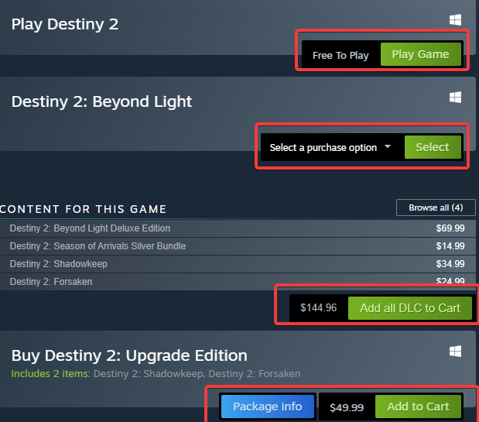

**Fig. 1, the store page for Destiny 2. Red boxes are added to highlight the confusing buttons.**

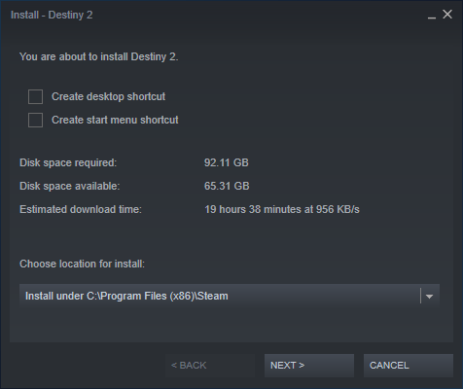

**Fig. 2, the installer prompt.**

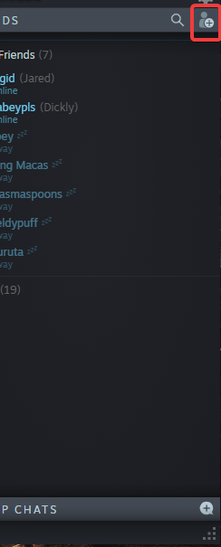

**Fig 3, the friends window. The add friend button is indicated.**

Trial 3

Questionnaire

1. Have you ever used a computer before? Yes.
   1. If so, how often? Daily.
2. Have you ever used Steam? No.
   1. If so, how often?
3. Have you ever played a computer game before? Yes.
   1. If so, how often? Monthly
4. Have you ever used a competing platform, such as Origin? No.
   1. Would you describe the other platform's experience as being better than Steam's?
5. Do you usually run Steam to do a specific task? N/A
6. What is usually the first thing you do when you run Steam? N/A
7. How many games are in your favorites list? N/A
8. Have you ever manually installed an update for a game? No
   1. Why did you install the update manually?
9. How do you usually add games to your Steam library? N/A
10. How do you normally communicate with friends while playing a game? My phone.
11. What was your most used function of Steam? Why? N/A
12. What was your biggest challenge/obstacle faced during the testing process? There was a lot of text and images everywhere to sift through.
13. Rank Steam experience (1-10) “1-Terrible & 10-Amazing” N/A

Flow Model

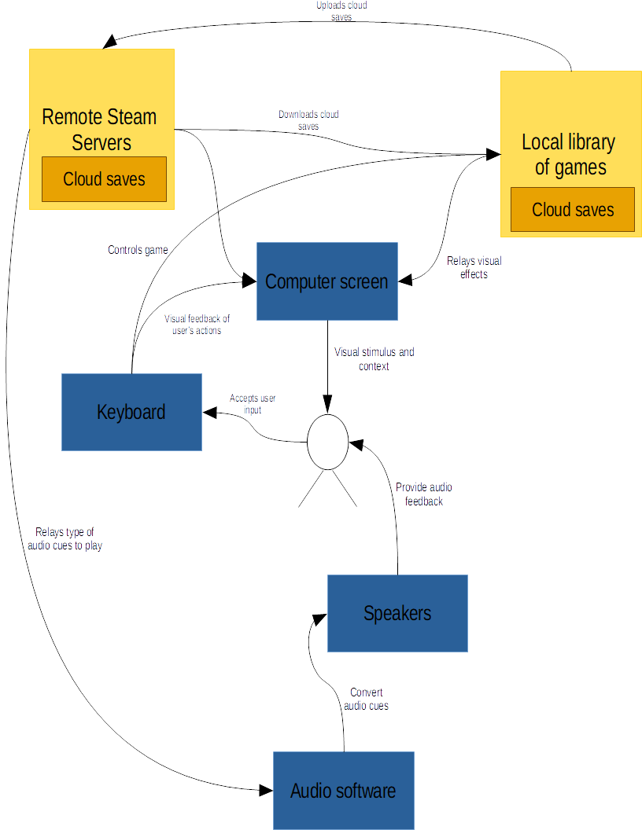

Social Model

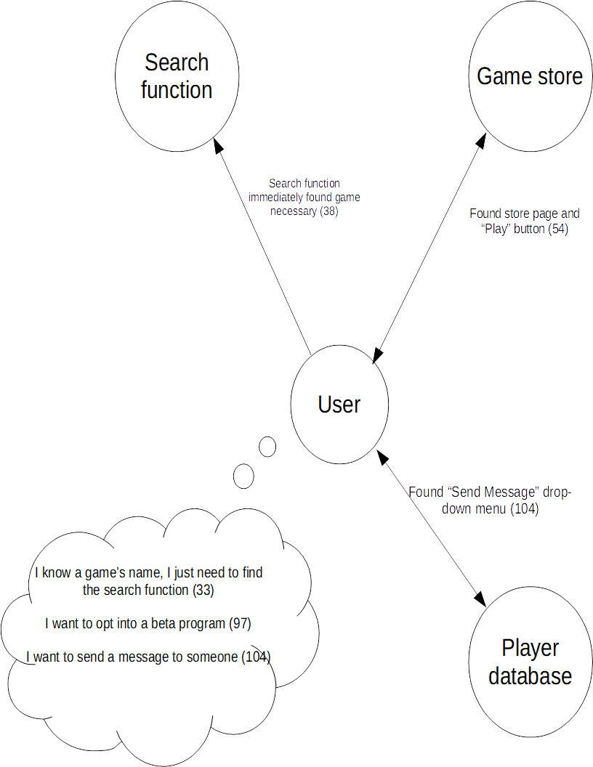

Takeaways

DO

* DO take your time. Steam’s layout is relatively straightforward. Looking around enough will allow any user to find what they’re looking for eventually.
* DO allow the drop-down search function work. There is a good chance that whatever game the user searches for will be there if the search terms are even remotely close.
* DO right click on games in the Steam library. This will allow the user to edit its properties, such as browsing the local files to create a desktop shortcut if they didn’t previously make one for a fresh install, among other things.

* DO single click with the left mouse button for all tasks.

DON’T

* DON’T click “Enter” when using the search bar. This will bring the user to Steam Labs, which might be overwhelming to first-time users.
* DON’T click “Start Voice Chat” on the Steam Friends menu. It is much too finicky to use reliably.
* DON’T try to message someone who is not already a steam friend.